***Question 1: Explain this following bash script:***

#!/bin/bash

space_free=$( df -h | awk '{ print $5 }' | sort -n | tail -n 1 | sed 's/%//' )

case $space_free in

[1-5]*)

echo Plenty of disk space available

;;

[6-7]*)

echo There could be a problem in the near future

;; 8*) echo Maybe we should look at clearing out old files

;; 9*) echo We could have a serious problem on our hands soon

;;

*)

echo Something is not quite right here

;;

esac

Solution:

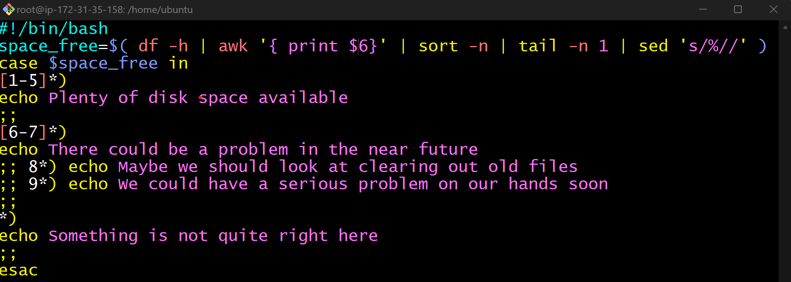



Now I have changed the value in print function,

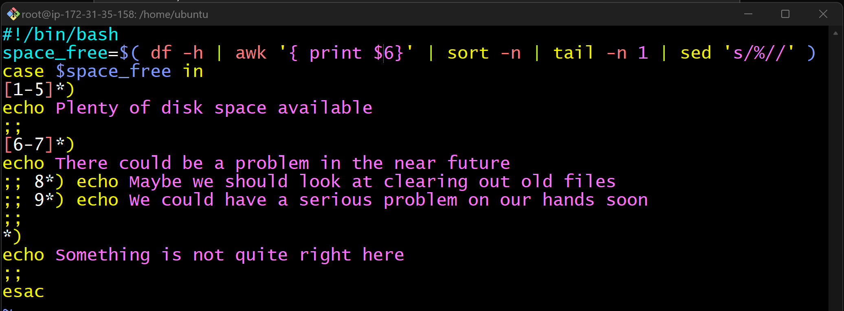

Now here is the output.



**Understating the syntax:**

**space_free=$( df -h | awk '{ print $5 }' | sort -n | tail -n 1 | sed 's/%//' )**

**case $space_free in**

**space_free**- This is the variable which we have set and to hold the value.

**df -h**- This is command is required to check the disk space.

**awk**- This is used for pattern scanning and processing and it searches the files to see if they contain lines that matches the specified pattern.

**print $5** – This function tells to perform field no, for example if we are putting $5 then it will print the 5th field.

**sort -n**- As name suggest, it is use for sorting.

**tail -n 1**- In scripting language we have head and tail method where head is use to print from beginning for file and tail is use to print from end of the file.

**sed 's**- It searches for the specified pattern in a file and replaces it with the wanted string.

**case $space_free in**- statement is generally used to simplify complex conditionals when you have multiple different choices